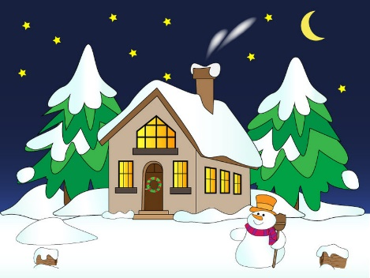**Keep fire safety in mind**

**as temperatures drop!**

**Havelock-Belmont-Methuen Fire & Emergency Services** is urging everyone to keep fire safety in mind as the temperatures turn colder.

We often see more home fires during the winter months due to heating equipment and appliances, pay close attention to potential fire hazards such as fireplaces, furnaces, chimneys and vents, and space heaters.

There are some simple things people can do to stay fire safe during the colder months:

* Have all fuel-burning appliances inspected annually by a registered fuel contractor.
* Keep chimneys and intake/exhaust vents for furnaces and heating appliances free of debris, ice and snow accumulations to reduce the risk of carbon monoxide (CO) build-up from inefficient combustion.
* Burn dry, well-seasoned wood in fireplaces and woodstoves to reduce the risk of excessive creosote build-up in chimneys.
* Allow ashes from your fireplace or woodstove to cool before emptying them into a metal container with a tight-fitting lid. Keep the container outside.
* Keep space heaters at least one meter (3 feet) away from anything that can burn, including curtains, upholstery and clothing.
* Replace worn or damaged electrical wires and connections on vehicles and extension cords and use the proper gauge extension cord for vehicle block heaters.
* Consider using approved timers for vehicle block heaters rather than leaving heaters on all night.
* Ensure that vehicles are not left running inside any garage or building.
* Ensure there is a working smoke alarm on every storey and outside all sleeping areas of your home.
* Install CO alarms to alert you to the presence of this deadly gas.

**HBM Fire & Emergency Services** reminds everyone that the Ontario Fire Code requires smoke alarms to be installed on every storey of your home and outside all sleeping areas. Carbon monoxide alarms are required outside all sleeping areas if the home has a fuel-burning appliance, a fireplace or an attached garage. For more information about smoke and carbon monoxide alarms, or fire safety, contact **Fire Dept. @** **705-778-3183.**